**Award Category: Best Customer Centric Culture**

**Customer Centricity in Edelweiss**

1. **Brief history about the company, management team and services / products / solutions offered.**

Edelweiss Group is one of India's leading financial services conglomerates, offering a robust platform, to a diversified client base across domestic and global geographies.

Our continuous and single-minded focus is on understanding customers’ needs and offering the right financial solutions. Being present in every financial life stage of a customer, helping them create, grow and protect their wealth, are our key lines of business. Its businesses are broadly divided into

* Credit (Retail, Corporate)
* Investment & Advisory (Wealth Management, Asset Management and Capital Markets)
* Insurance (Life, General)

This diversified business model reflects our experience across India's multiple consuming facets, from industrial behemoths and large companies to small business as well as the average Indian urban and rural household.

Our 1.2 million strong client base is serviced through a network of over 476 offices, with close to 11,000 employees. Together with a strong network of Sub-Brokers and Authorized Persons, the Group has a presence across all major cities in India.

**Edelweiss Investment & Advisory (EGIA)**

Edelweiss Investment & Advisory (EGIA), part of the Edelweiss Group, is one of India’s foremost wealth & asset managers with over INR 1060 billion in assets under advice. EGIA’s highly customized approach to creating wealth for our clients is supported by a robust and cost-effective business model focused on improved transparency and compliance, synergistic partnerships and efficient technology solutions. We offer a differentiated value proposition to our customers, which is delivered through specialists financial advisors as well as through a digital platform.

Since inception, a set of guiding principles have governed our operations and have helped clarify and guide decision-making, however challenging the circumstances. Our thirteen principles reflect all the values that define us, breathing life into our credo - 'Ideas Create, Values Protect'. They ensure that each employee is guided by a common vision. As our guiding light, they have aided us in creating value for our stakeholders year after year, while steering our ambition so that we always stay true to our values

**Our Vision is to become the most preferred advisors in India by providing Unbiased Advisory, Simplicity and Personalization**

1. **Description of the product or service for which your company is entering this award category**

***Our initiatives of “Customer Centricity” in the past 12 months***

At Edelweiss we believe in providing the right product to the right customer at the right price, and placing the customer foremost at all times.

This approach of listening to the customer and understanding their needs helps us craft solutions and not just sell products. This is aligned to our corner stone philosophy of "Suno, Samjho, Suljhao".

Some initiatives carried out in this regard in the recent past are as follows:

1. **Continual Improvement on NPS as metric to measure client experience:**
2. **Client Engagement Score**
3. **Customer Centricity Initiatives**

We started our journey towards client centricity 9 years ago with organizational initiatives like:

* Launch of “Suno, Samjho Suljhao” campaign
* Creation of an independent CXO (Client Experience Office) team with a huge emphasis on customer feedback and various other client centric initiatives
* Empowerment of CXO office to approve release of new products, communications, to ensure Client interest is focused on

1. **Continual Improvement on NPS as metric to measure client experience:**

**Work done till now:**

NPS is the Customer success metric which measures customer loyalty towards the organization . talking directly to our own customers and finding out their thoughts on our business specifically. The opinions they share will tell us exactly where your business is successful and where we might need to make changes.

Seeking client feedback is an ongoing initiative across the company and improvement in Net Promoter Score is a key differentiating factor represented across the organization to assess and improvise as to how the customer loyalty towards the business stands.

The goal is to get a periodic pulse on our customers and understand how they feel about our company overall. The data is be used to check the health of customer year-over-year and provide a benchmark for our success. NPS survey is used to understand customer satisfaction on a granular level and provide feedback about a very specific topic.

Customer success management is all about keeping customers happy. NPS helps us identify  [Customer success platform](https://www.gainsight.com/guides/the-essential-guide-to-customer-success/) which enables up-sell opportunities, reduces churn, and increases the profitability. Net Promoter System also requires a process to close the loop. In closing the loop, we actively intervene to learn more from customers who have provided feedback, and also to change a negative perception, often converting a Detractor into a Promoter

The scores derived from these surveys help us identify the strengths and ares of development . and a way to maintain focus on our culture.

These scores are an important parameter that is assessed by The Board of Directors whilst considering the performance growth of any business unit. This impetus from the Chairman’s office, the Board and senior management has gone a long way in ensuring that the processes have been consistently been aligned to the customer.

Below is the representation of how we have progressed in driving & improving the customer feedback since inception:

* NPS Score – Was 3 in Q1FY15 to 37 Q3FY19- Positive Feedback has moved from 54% to 92% and Unhappy Score of customers reduced from 27% to 12%

The above numbers are reflective of our endeavor and efforts towards becoming a more customer-centric organization & rigorous implementation of the following deliverables:

* Capturing monthly feedback from about 500 unique clients to understand their sentiment.
* Close looping of all negative feedback within 48 hours of feedback getting registered
* Detailed monthly review with all Stakeholders – to ensure Un-Happy (Detractor) score stands improvised on a month on month basis.
* All Corrective & Preventive action are implemented and are measured on a regular basis to ensure sustained performance
* Also starting July, we sought feedback from client’s basis their age group. This was primarily undertaken to gauge customer loyalty across age groups and evaluate expectations.
  + July - Our focus was towards Millennials (clients born between 1981 -1996 – age between 23 - 37 years).
  + August – We reached out to Gen X (clients born between 1965 -1980 – age between 38- 53 years) and
  + September - Our target audience was Baby Boomers. (Clients born between 1946 -1964 – age between 54- 73 years).

We had some very interesting observations such as– (i) Baby Boomers & Millennials were more happier with Edelweiss as compared to Gen X (ii) Millennials were satisfied with our Platforms (Trading systems) however expect better services from Relationship Managers. (iii) Gen X had concerns with Brokerages and charges and need more handholding on trading systems. (i) Baby Boomers were aligned to Brokerages & charges and expect better connectivity with their Relationship Managers.

* Edelweiss’s foray in the major metro has been majorly up to the mark. To synchronize with our overall aim of being the one stop wealth management entity across the length and breadth of the country for the month of December, we have reached out to clients in Tier Two cities like Rajkot, Surat. Based on initial feedback, we observe clients in these cities need more handholding assistance so that they are able to better utilize the platforms.

Insights of such sort have proved very helpful in ascertaining and providing a direction and more importantly build a culture that puts the customer at the centre and align our objectives around their needs

**Plan ahead:**

Using a Net Promoter System, we can do more than just send out one question surveys to understand how likely a customer would recommend our product/service/company to someone they know. We can follow up quickly to close the loop on pain points, identify drivers in the company that are creating promoters and detractors, predict future churn trends to Improvise our NPS scores .

At the Edelweiss level we have commenced our Digital NPS Journey by partnering with Litmus World (<https://www.litmusworld.com/>). Using a Net Promoter System, we can do more than just send out one question surveys to understand how likely a customer would recommend our product/service/company to someone they know. A more cost effective way but the intend being we are able to take feedback from a larger number of customers.   From a client experience view point, it will help us in getting real time feedback from clients and close loop negative feedback within a max of 48 hours. We can also identify drivers in the company that are creating promoters and detractors, predict future churn trends to Improvise our NPS scores .We also see a benefit and create customized reports that analyse NPS ratings by customer type , real time dashboards with drill down reports across all demographics – across LOB’s, Zones, Regions, Branches, being readily available for the management to view and take corrective action. These reports can also help us understand different types of customer sentiment and improve the experience based on the type of customer

1. **Client Engagement Score:**

As a part of our endeavor to ensure clients are effectively engaged- We introduced “Client Engagement Score”. The higher the score, the healthier and happier the customer. We evaluated the customer engagement score, by considering the following touch points i.e.

* Conversation undertaken between the RM & Client
* Meetings undertaken between the RM & Client
* Trading / Transaction
* Client Visit (Online Platforms – Such as Website, Mobile App)
* Fund Transfer
* Responded to client communication

You can then group customers into segments as High, Medium, Low or Not Engaged clients and collate feedback accordingly . The categorization will also help us to see how the segment is performing compared to other segments, and identify at-risk customers within those segments.

Regular internal campaigns are devised to ensure clients migrate from Low and Not Engaged to Medium and High Engaged clients.

Algo’s have been designed such that tasks are assigned to the respective RM’s and client meetings are conducted on a regular basis.

Campaigns to improve client’s involvement via Platforms are also regularly implemented. These campaigns involved activities like – motivating the clients to download the app which enables direct communication with the client and effective in engaging with the clients interest , view research recommendations, provide insights on various products.

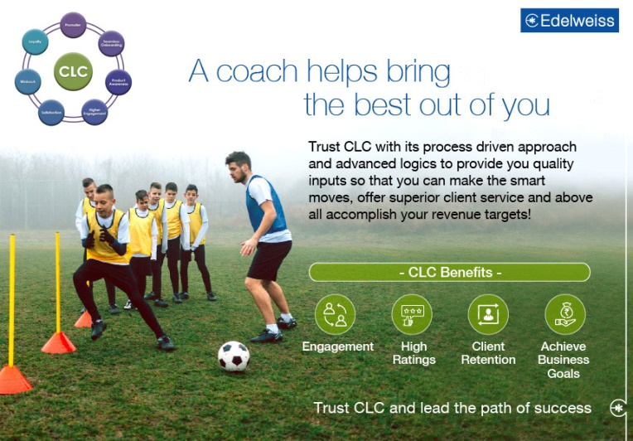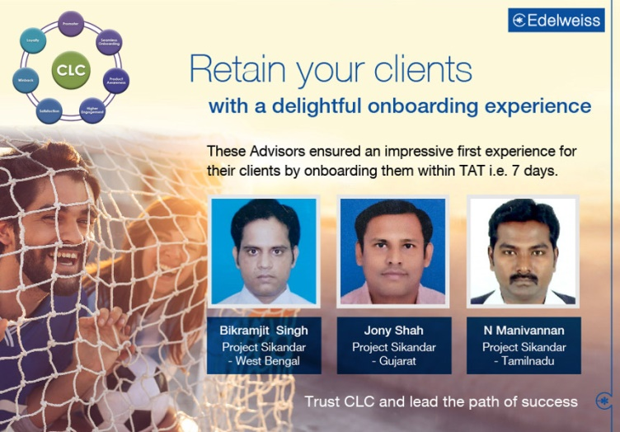We observed with the implementation of CES a 20% increase in revenue was observed between the duration of April 2019 to Sept 2019 – (First six months of its implementation)

1. **Customer Centric Initiatives based on Voice of Customer.**

Voice of the Customer (VOC) – While Understanding the importance of customer centricity, on a monthly basis, we do a complete deep dive into feedback, queries, requests & complaints. We understand customer expectations, preference & aversions and how the industry is interacting with their customers and accordingly action plan is put in place to improvise customer experience across all touch points.

The following customer centric initiatives were undertaken as a direct result of implementation of **Voice of the Customer.**

1. Commodity Clients – Requirement of Market Update. During the period Jan to March 2019 we received feedback from clients trading in commodities that they needed regular updates on commodities during market hours. Taking this feedback into consideration a “**Commodity Dashboard Research Report**” was created and it went live around 10th April 2019. It is published twice in a day at 9:15 am and 4:30 am and aims to give the commodity customers an understanding on the commodity market status for the day.

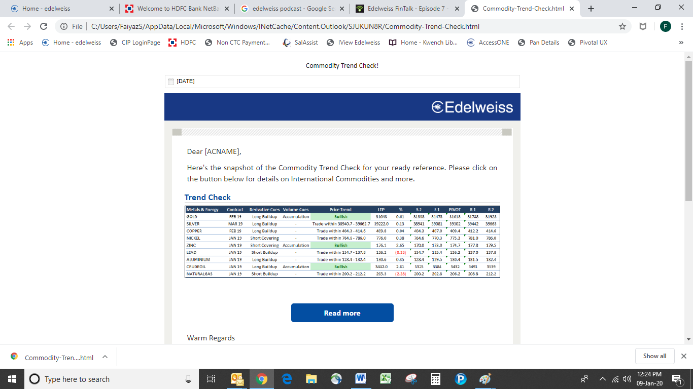

1. **Corporate Actions for FNO Segment**– Whilst the exchange website has the necessary details pertaining to Corporate Actions, quite a few of our clients complained of not being aware of major corporate actions like dividends getting issued or stocks getting split, bonus getting declared, mergers getting announced.

Hence in the month of July 2019 - Edelweiss automated this process such that whenever we receive intimation on corporate actions while stocks are in the FNO segment - clients would receive intimation via SMS, App Notification as well as via Email immediately about the effect of the relevant corporate action

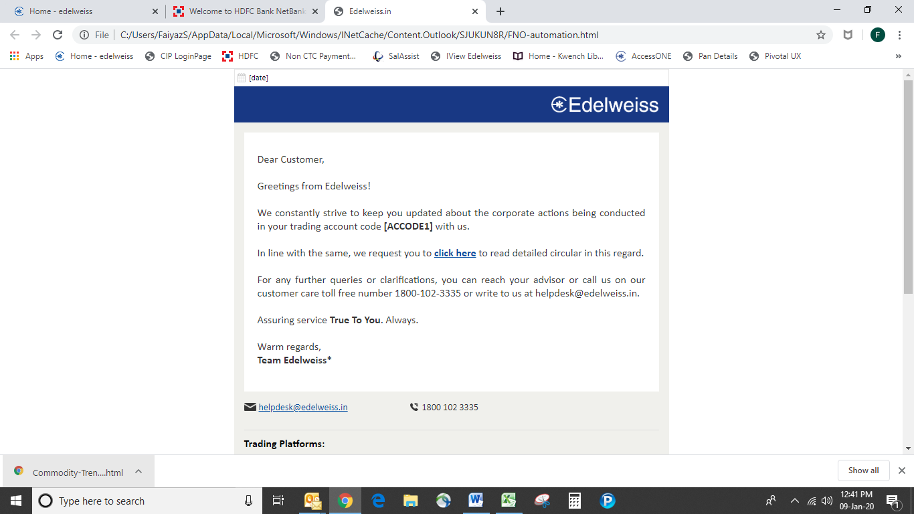

1. **UPI Payments for Margin shortfall** – Investing in stock market involves a considerable amount of risk and during market volatility clients usually face the risk of shares being liquidated due to margin shortfall. Clients faced numerous difficulties during such conditions to make payments to cover margin shortfall. To overcome this pertinent client issue, starting July 2019, we trigger an SMS to respective customers regarding the tentative margin shortfall in their trading account and also provide them a UPI payment link which 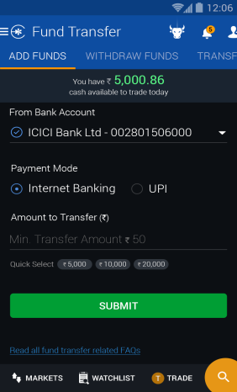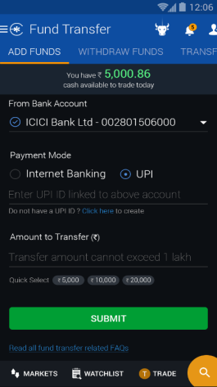allows the customer to transfer the funds on the go.
2. **Winning back unsubscribed clients**: It’s observed during market volatility clients tend to panic and stop investing. As a knee jerk reaction, they also unsubscribe from all promotional mailers – not realizing that it could be the best of times to invest. In September 2019, for the first time ever, we undertook a survey seeking feedback from clients who had unsubscribed from our research communications, highlighting the investment journey. In response to our survey, we got about 1250 clients who had earlier unsubscribed.

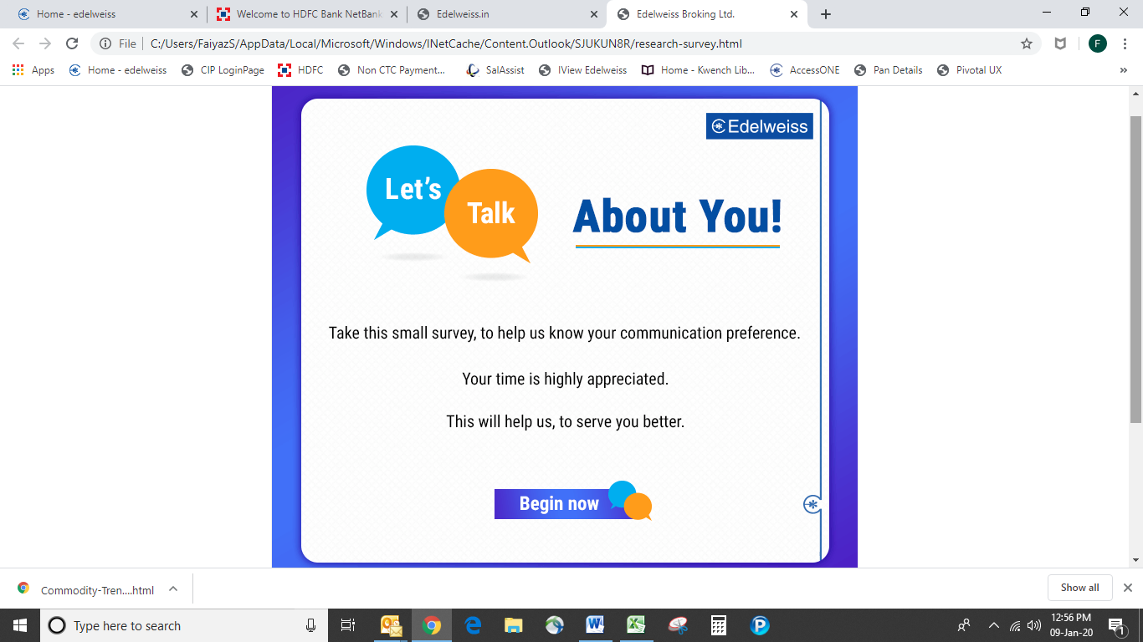

1. **Proactive Regular Updates**: Regular proactive updates are sent to customers for submitting income declaration, CKYC, KRA details. Regular reminders are sent to keep the trading accounts funded especially during volatile markets. To confirm correct DP details – which prevent liquidation of stocks.
2. **Podcasts** : Normally clients perceive managing money to be quite difficult and a complicated affair. The aim of ‘Bite-size’ podcasts was to dispel the myth that money management is complicated. A microsite (<https://edelweissfintalk.podbean.com/>) is dedicated for these podcasts. About 2 to 3 podcasts are hosted every month, as on date we have hosted 27 podcasts with both internal as well as external – industry experts. Some of the interesting topics covered were Asset Allocation, Financial Goals, Financial Freedom, How to choose Mutual Fund as a Beginner, Money Disorder – A self-limiting financial behavior, Managing Finance during your first job, marriage and child, Active v/s Passive Investing. As on 31st December 2019, a total of XXXX viewers have benefitted from these podcasts

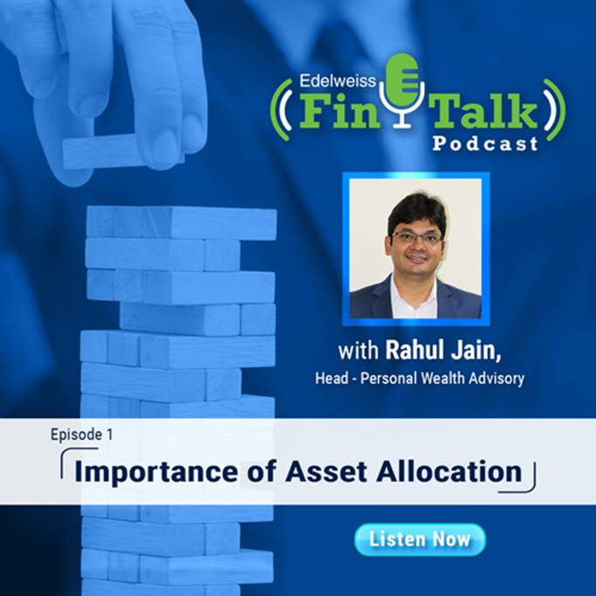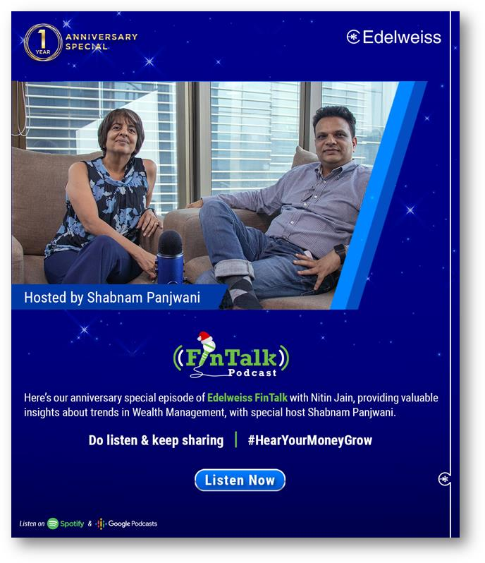

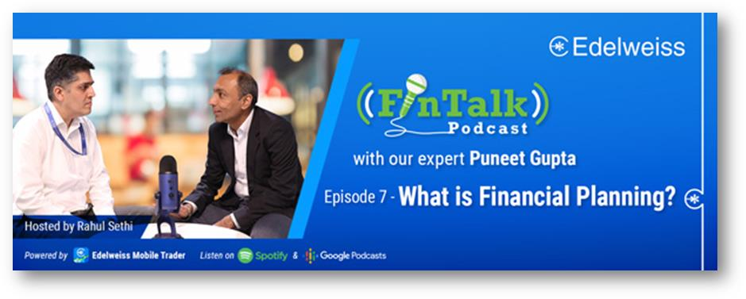

1. 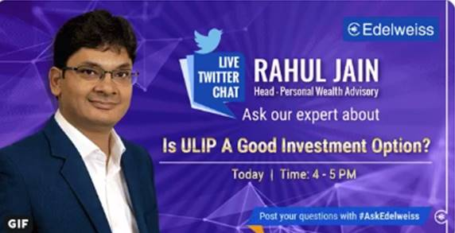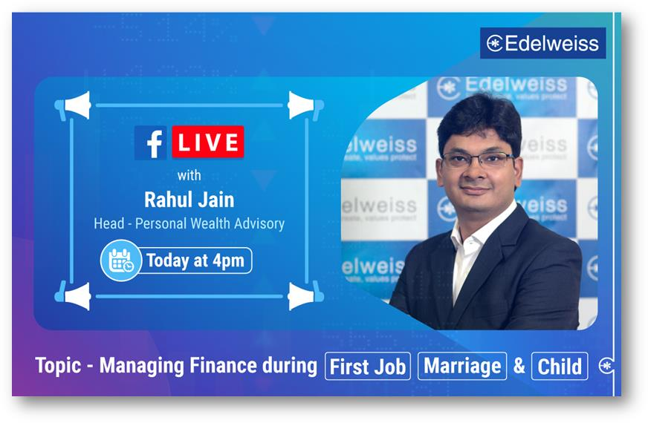**Other Initiatives on Social Media:** Apart from Postcasts, we also have Facebook and Twitter live hat sessions with Rahul Jain. Aim here being to make investing simpler for Edelweiss and has been made available such that even visitors can view these clips.

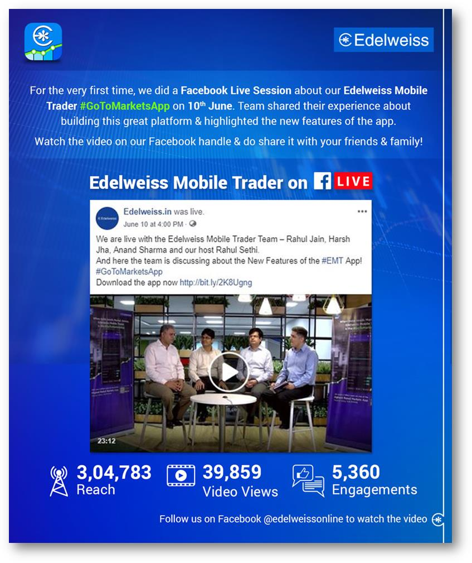

1. **Platform based initiatives:** The following are the Platform based initiatives undertaken by us at Edelweiss to ensure we provide the best level of customer experience

**LITE Plan**: In the month of September 2019, we introduced a Lite plan to acquire new age customers who are tech savvy, prefer the DIY option and expect competitive pricing. It was most suited for clients who required the following

* Fixed costs on trades
* Largely self-driven or DIY in nature
* Require access to standard features & products
* Do not need any advisory assistance

It is largely meant for users who enjoy using digital platforms and largely invest / trade using them.

**Live News**: The live news on Edelweiss Mobile Trader has been one of the most successful initiatives. Unlike providing detailed business news, it provides headlines / snapshots of news which is relevant for traders. It has been appreciated by a lot of customers who found it very useful during trading hours.

Snapshot…. Appreciation

**Small Case Offering**: This offers a bouquet of research reports to our retail clients. This research is sourced across various websites and offers customers a plethora of research to choose from.

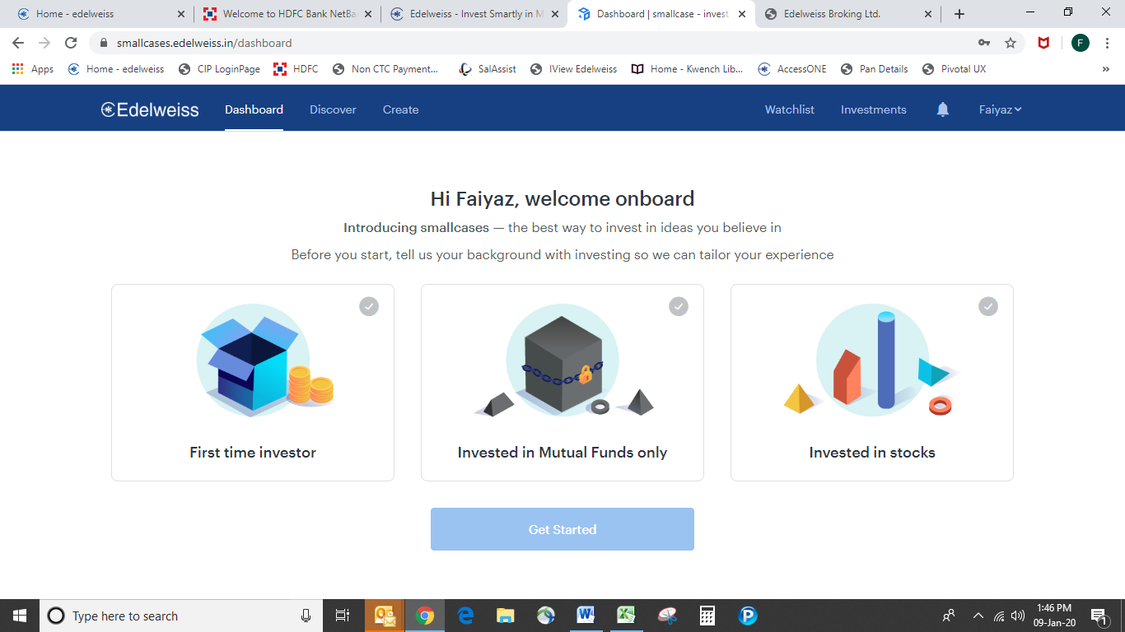

**Advanced screeners**: Advanced screeners offers traders about eight predefined queries in the form of screener. The following tool is yet another very useful tool for traders to take immediate decisions.

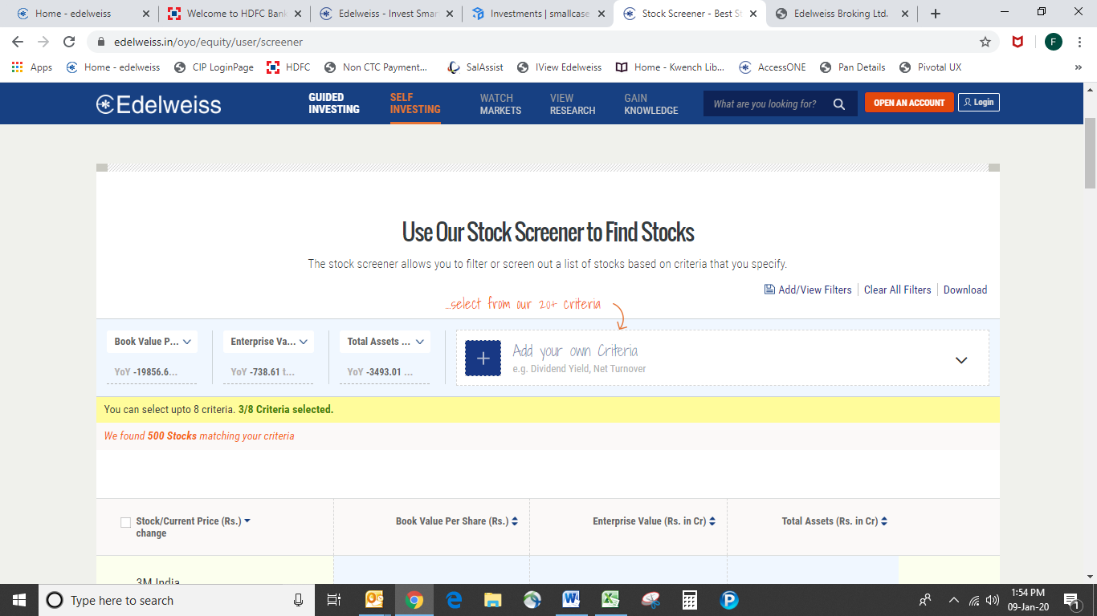

**Online IPO Application:** Clients of Edelweiss were unable to apply for IPO via the Edelweiss Platforms. We have now enhanced our website such that all that a client needs to undertake is to enter the bid details on our website, the UPI ID linked to the client’s bank account (where he wants to block the funds) and using the UPI app and accept the blocking request to complete the application process. This feature has also been very much appreciated by our clients.

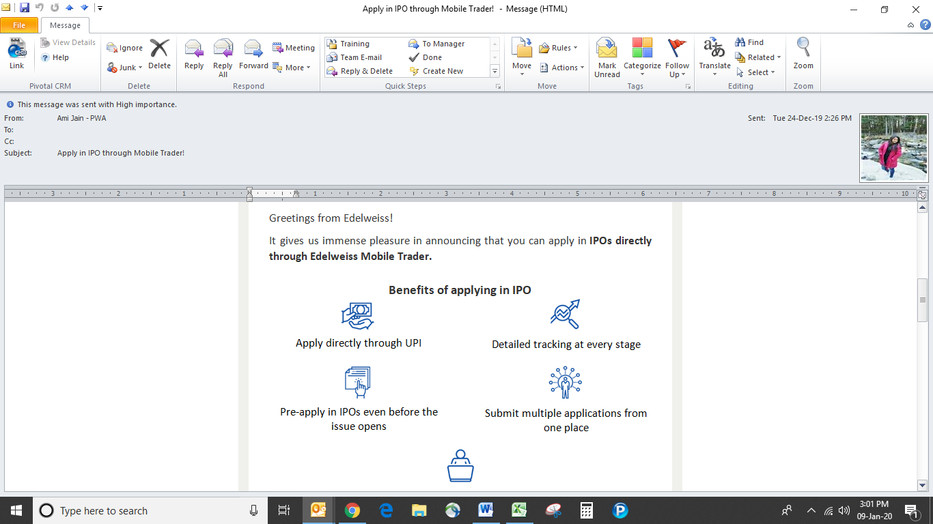

Apart from the above major features we also provided a 3D touch, Picture in Picture (PIP), Bull customization feature on our App.

**CX Champs Reward: CX Champs Reward** is a monthly program where employees are awarded for having provided high levels of customer service. Nomination is based on six values:

* Accessibility – RM is available for the clients at all points of time.
* Same Side – RM would listen to customers with empathy. Understands and resolves their problems and will align his actions to their needs
* Upfront – RM will be transparent in dealings, communicate all relevant risks and ensure that the client understands them clearly.
* Remove limitations – RM will strive to squash all obstacles for his customers, so that they can achieve their aspirations
* Easy to deal with – RM will uncomplicated and will simplify. Will make it a pleasure to work with him
* Dependable – RM will take complete ownership of the solutions and will deliver them gto the customers.

These nominations are then approved by the Head CXO in each Business Unit and approved CX Champs are recognized every month at the group level

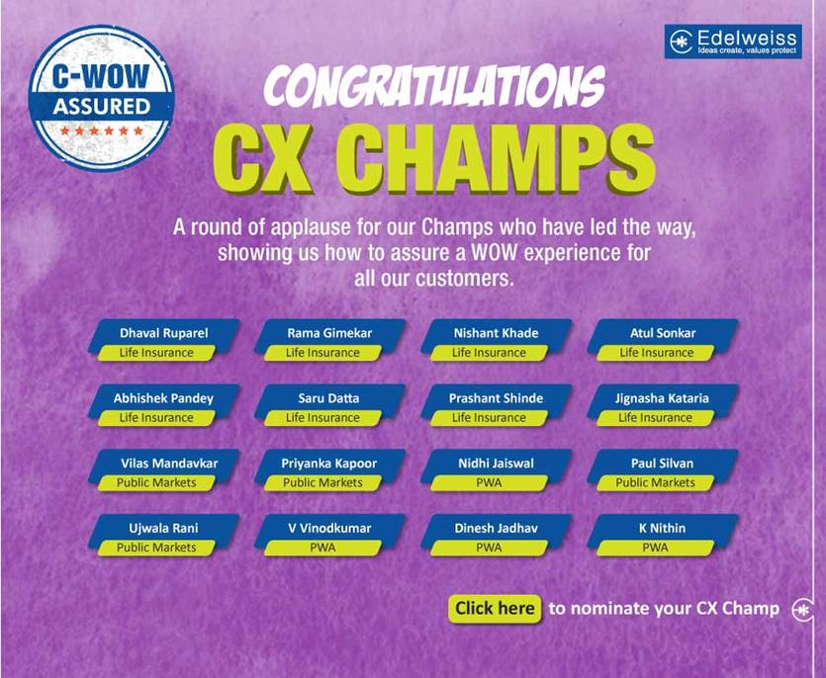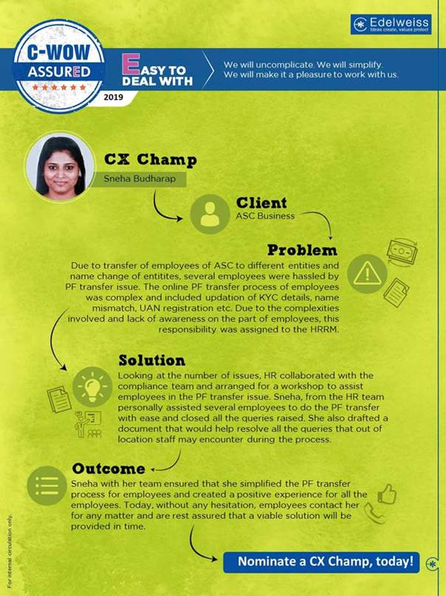

1. **Why your company should be shortlisted in the top 3 nominees to compete for this award.**
   1. Edelweiss as a brand is well known for adopting transparency & risk culture. These values have helped us in our journey to being Top 3 amongst our competitor

Client Centric Culture has a huge say in assessment of business growth for every business unit.

* 1. Edelweiss has a top down approach for running customer initiatives. Motivation to implement at ground comes from the Chairman, the Board and senior Management
  2. Edelweiss is pioneer in capital market industry to drive the customer centric culture by adopting NPS methodology culture in addition to our core values
  3. Most companies have profitability at their centre and revolve their business around them. We at edelweiss have the **customer at our centre and revolve the business around them.**

1. **What three measurements of success best indicate why your company should win this award finally?**
   1. Client metrics have improved continuously from inception & 88% of our customers are ambassadors of Edelweiss brand:
      1. NPS Score – 3% in Q1FY15 to 37% Q3FY19
      2. % of Positive feedback improved from 54% during 2014-15 to 92% during Dec 19
      3. % of Detractors or Un Happy Customers reduced 27% during 2014-15 to 12% during Dec 19
   2. Continuous implementation of Customer Centric initiatives has resulted into increase in total client base of organization. Our total client base has increased by XX% in Dec 2019 compare to FY 2014 -15
   3. The global recognition that we have received in recent years is a strong testimony of the trust our clients place in us and an inspiration to continue to excel in all that we do.

The awards and accolades Edelweiss has recently won that triumph our success:

* + 1. Latest ones are not held
    2. Best Corporate Governance – India 2017 – CFI.co Corporate Governance Awards
    3. Wealth Management Excellence Awards (GWM) 2017 – The Economic Times Premium Brands
    4. Best use of Mobile Technology in Financial Services (EBL) 2017 – The APB News BFSI Awards
    5. Gold for Digital Marketing Excellence 2017 – Financial Services Sector at DIGDOC
    6. Risk Management Team of the Year 2017 (Edelweiss Risk Group) – CRO Leadership Summit & Awards 2017
    7. Best Research Analyst Organization 2017 – Assocham Capital Market Intermediaries Excellence Awards 2017
    8. In-House Professional – Banking & Financial Services – Fulcrum Awards 2017
    9. Leader in Employee Volunteering (Edelweiss Financial Services) - iVolunteer Awards 2017
    10. Best Performing Institutional Member (Edelweiss Securities Limited) – NSE Market Achievers Awards 2017
    11. Bronze award at the 2017 ARC Award – Traditional Annual Report Category
    12. Best Wealth Manager – Rising Star, India 2017 (Edelweiss Private Wealth Management) – The Asset, Hong Kong (Asia’s leading business magazine)
    13. Best Performance - Asia Pacific, Best Distributor – South & Southeast Asia, Best Distributor (India),Best Performance (India) – Edelweiss Structured Products – SRP Asia Pacific Awards 2017